WEEK 5 ASSIGNMENT | PRODUCT MANAGEMENT INTERNSHIP
Go-to-Market & Launch Strategy
ShopSphere 2.0: "Shop with Confidence". Segmentation, positioning, marketing mix and a step-by-step launch plan for an Indian fashion and lifestyle e-commerce platform
Prepared by: [Your Name]
Organisation / Program: [Internship Program Name]
Date: October 2026
Note: This plan continues the Week 4 customer journey study and the final-week performance evaluation for the representative platform "ShopSphere". Market figures are indicative estimates built from public sources and stated assumptions; all internal figures are simulated. Verify festival dates and market data before real-world use.

Contents

1. Executive Summary
Weeks 4 and 5 of this internship diagnosed ShopSphere's problem: shoppers like the product range but leave because of surprise costs, size doubt and uncertain returns. This document turns the proposed fixes into a launch. ShopSphere 2.0 ("Shop with Confidence") bundles the highest-impact improvements into one proposition and launches it ahead of the 2026 festive and wedding season.
The plan in brief
- What we launch: ShopSphere 2.0 combines transparent total pricing, guest and OTP checkout, fit guidance with photo reviews, a delivery date by pincode, and easy self-serve returns.
- Market: Of an estimated Rs 72,000 crore online fashion and lifestyle market, ShopSphere can serve about Rs 25,200 crore. The Year-1 target is Rs 39.4 crore GMV (about 0.16% of the serviceable market, up 50% from the current run-rate).
- Targets: Five segments were scored. "Festive Planners" (S1, score 4.40) is the beachhead, and "Trust-Seeking Tier-2/3 Shoppers" (S3, score 3.95) is the second wave.
- Positioning: "For style-conscious online shoppers who are tired of guessing size and price, ShopSphere is the fashion platform where you can fit it, trust it and keep it." Differentiators: fit-first discovery, no-surprise pricing and fast, easy returns.
- Investment: A Rs 75 lakh marketing budget over 10 weeks, plus a Rs 16 lakh first-order and referral offer fund, is projected to bring about 17,724 new customers at a blended CAC of Rs 381 (versus Rs 421 today).
- Timeline: Readiness and build (5 to 23 Oct), pre-launch beta and teaser (19 Oct to 1 Nov), launch day on Monday 2 November 2026, and a post-launch optimisation phase with formal reviews at D+7 and D+30.
Return: at current assumptions the new-customer cohort pays back 114% of media spend over 12 months (0.72x at 90 days), and the conversion improvements on existing traffic add the Rs 28 to 62 lakh per quarter estimated in the performance study. The plan is deliberately staged, with go/no-go gates and feature flags, so that it can be paused or rolled back if early signals are weak.

2. Launch Scope and Objectives

2.1 What Is Being Launched
ShopSphere 2.0 is a relaunch of the existing mobile-first marketplace, not a new company. It is a proposition upgrade supported by product changes, a fresh brand message and a festive-season campaign. Launch scope was limited to improvements that are low to medium effort and passed QA by 23 October.
Launch pillar | Features at launch (MVP) | Customer problem solved
Honest price | Total price shown from cart; free delivery above Rs 1,499; no late fees | Surprise costs (top abandonment reason)
Faster checkout | Guest checkout, phone-OTP login, 5-field address with pincode lookup, UPI intent, payment retry | Forced sign-up, long forms, payment failure
Fit confidence | Fit tags from reviews, model measurements, photo reviews, size-help prompt (full fit assistant in beta) | Size and quality doubt
Delivery promise | Delivery date by pincode on every product page; WhatsApp order updates | Uncertainty about arrival
Easy returns | Self-serve returns in 3 taps, exchange-first option, pickup scheduling, 2-day refund target | Fear of return hassle

2.2 Launch Goals
- Adoption: Drive adoption: acquire first-time buyers and re-activate lapsed customers around the new proposition.
- Conversion: Improve conversion and checkout completion on all traffic, not only on new customers.
- Brand: Establish "fit, trust and easy returns" as ShopSphere's identity in target segments.
- Profitability: Keep contribution per order healthy: offers are capped and funded within a defined budget.

2.3 Targets
Metric | Baseline (Q3) | Day 7 | Day 30 | Day 90
Conversion rate | 1.18% | 1.25% | 1.35% | 1.50%
Checkout completion | 48.4% | 51% | 53% | 54%
Payment success rate | 86% | 90% | 91% | 92%
Waitlist sign-ups (pre-launch) | - | 40,000 by L-Day | - | -
New customers (cumulative) | - | 3,500 | 12,000 | 17,700
Blended CAC | Rs 421 | Rs 450 or lower | Rs 400 or lower | Rs 385 or lower
App share of orders | 52% | 54% | 56% | 58%
Return rate | 28% | 28% | 27% | 25.5%
NPS | 31 | 33 | 36 | 40

2.4 Key Assumptions
- The Week 4 and final-week improvements marked "quick win" are available to launch by 23 October; any item that fails QA launches later behind a feature flag.
- Logistics partners can hold the delivery promise through the festive peak, and support is scaled for 2x volume.
- Marketing budget and offer fund are approved by 9 October.

3. Market Analysis

3.1 Public Market Insights
The insights below come from publicly available research and shape the plan. Figures are indicative; check the latest editions of the sources before quoting them externally.
Trend | Public insight | Implication for ShopSphere
Mobile-first, digital India | India has over 900 million internet users, mostly on smartphones (TRAI, IAMAI). | Design and campaigns are app-first; speed matters.
Growth from smaller cities | Most new online shoppers come from Tier-2 and smaller cities (Bain and Flipkart, Redseer). | Tier-2/3 trust and COD options are the next growth wave.
UPI-led payments | UPI handles well over 15 billion transactions a month (NPCI). | UPI intent and retry are essential; reduce card friction.
Festive concentration | A disproportionate share of annual online sales falls in the festive window (Redseer, Bain). | Launch just before Diwali; protect uptime and delivery.
High fashion returns | Fashion return rates of roughly 20 to 40% are widely reported for Indian platforms. | Fit tools and easy returns are a profit lever and a message.
Creator and social commerce | Short video, creators and WhatsApp influence discovery and trust (industry reports). | Creator seeding and WhatsApp CRM are core channels.
Faster delivery expectations | Large platforms are piloting ultra-fast delivery in metros. | A reliable delivery date is a minimum, not a bonus.

3.2 Market Sizing (TAM, SAM, SOM)
A bottom-up estimate is used. The inputs are assumptions based on public ranges and should be replaced with company data as it becomes available.
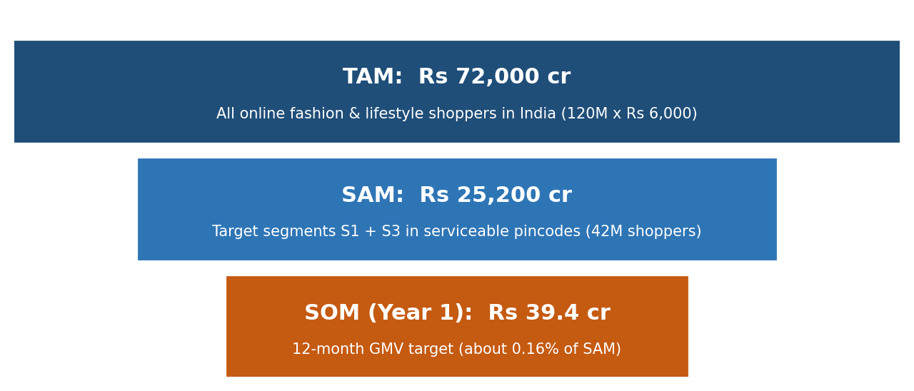
Figure 1: Market sizing funnel (estimates)
Step | Calculation | Result
TAM: online fashion and lifestyle shoppers | 120 million shoppers x Rs 6,000 annual spend | Rs 72,000 crore
Target segments (S1 + S3) | 22% + 28% of shoppers | 50% = 60 million
Serviceable pincodes | 70% of target shoppers reachable with delivery promise | 42 million shoppers
SAM | 42 million x Rs 6,000 | Rs 25,200 crore
Current run-rate | Q3 GMV Rs 6.57 crore x 4 | Rs 26.3 crore
SOM (Year 1 target) | Run-rate x 1.5 | Rs 39.4 crore (0.16% of SAM)

The Year-1 target is a small share of the serviceable market, so the constraint is execution and trust rather than market size.

3.3 Competitive Landscape
Direct competitors are large fashion and general marketplaces. The ratings below (1 = weak, 5 = strong) are an illustrative analyst judgement from public information and user reviews, not measured data.
Attribute | Myntra | Ajio | Amazon Fashion | Meesho | Nykaa Fashion | ShopSphere today | ShopSphere target (12 mo)
Assortment breadth | 5 | 4 | 5 | 4 | 3 | 3 | 3
Price value | 3 | 4 | 3 | 5 | 2 | 3 | 4
Fit confidence tools | 4 | 3 | 3 | 1 | 3 | 2 | 4
Returns ease | 4 | 3 | 4 | 2 | 4 | 2 | 5
Delivery speed | 4 | 3 | 5 | 2 | 4 | 3 | 4
Tier-2/3 reach | 3 | 3 | 4 | 5 | 2 | 3 | 4

Large players win on range and delivery speed, and value players win on price. No one clearly owns the combination of affordable pricing and high shopping confidence, which is the opening ShopSphere targets.
SWOT summary: Strengths are a mobile-first stack, a clear journey diagnosis and a focused, fixable set of friction points. Weaknesses are a modest brand, limited ad budget and a thin fit-data history. Opportunities are growth from smaller cities, the festive spike and underserved fit anxiety. Threats are competitor discounting, rising ad costs and logistics strain at peak.

4. Segmentation and Customer Personas

4.1 Segmentation Approach
Segments are built on a blend of four lenses: demographic (age, income, city tier), behavioural (device, payment preference, purchase occasion), needs-based (what the shopper is trying to achieve) and psychographic (attitude to risk, price and brands). Needs and behaviour define the segments; demographics help find and reach them.

4.2 Segment Profiles
Segment | Description | Share of shoppers | Market (Rs crore) | Core need and main barrier
S1 Festive Planners | Women and men aged 24 to 35 in metros and large Tier-2 cities; occasion buyers | 22% | 15,840 | Need: occasion outfits that fit and arrive on time. Barrier: size doubt, delivery uncertainty.
S2 Budget Starters | Students and first-job shoppers aged 18 to 24; very price-aware | 20% | 14,400 | Need: trendy looks at low prices. Barrier: low basket, high price sensitivity.
S3 Trust-Seeking Tier-2/3 Shoppers | Aged 25 to 40 in smaller cities, newer to online shopping; COD-friendly | 28% | 20,160 | Need: reliable, genuine products. Barrier: trust, payment fear, return anxiety.
S4 Family Shoppers | Parents aged 30 to 45 buying for family and home | 18% | 12,960 | Need: one-stop bundles and sizes for many people. Barrier: multi-size returns, delivery windows.
S5 Practical Men | Men aged 25 to 40; buy few items, know their size | 12% | 8,640 | Need: quick repeat buys. Barrier: low engagement with fashion content.

4.3 Segment Attractiveness Scoring
Each segment is scored from 1 (low) to 5 (high) on five criteria, weighted by importance. Strategic fit and profitability carry the highest weight because the performance study showed that growth without margin is not sustainable.
Segment | Size (20%) | Growth (15%) | Fit (25%) | Reach (15%) | Profit (25%) | Weighted score | Decision
S1 Festive Planners | 4 | 4 | 5 | 5 | 4 | 4.40 | Primary (beachhead)
S2 Budget Starters | 3 | 4 | 3 | 5 | 2 | 3.20 | Opportunistic via referral
S3 Trust-Seeking Tier-2/3 Shoppers | 5 | 5 | 4 | 3 | 3 | 3.95 | Secondary (wave 2)
S4 Family Shoppers | 3 | 3 | 3 | 3 | 4 | 3.25 | Monitor
S5 Practical Men | 2 | 3 | 3 | 4 | 3 | 2.95 | Monitor

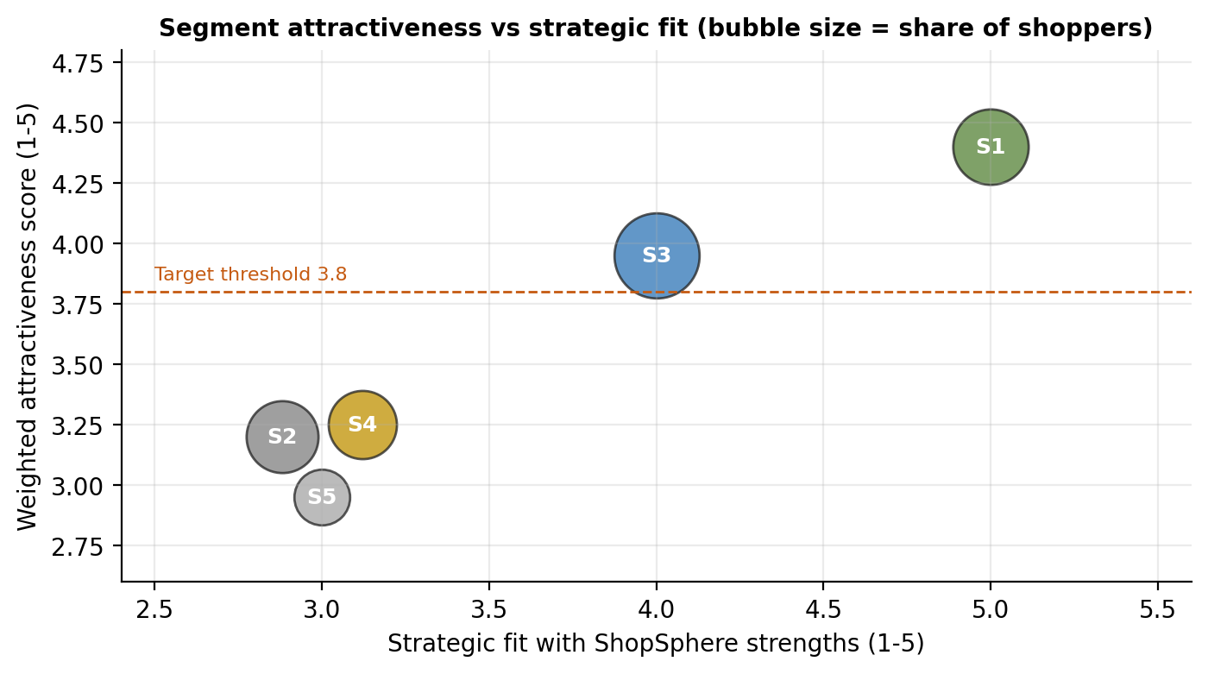
Figure 2: S1 and S3 clear the 3.8 threshold; the others do not
Targeting decision: S1 is the beachhead because it combines high fit, strong reachability on Instagram and WhatsApp, and good profitability (higher baskets, occasion urgency). S3 is the largest and fastest-growing pool and benefits most from trust features, but needs COD, regional language support and lower-cost reach, so it follows in a second wave from December. S2 is served opportunistically through referrals. S4 and S5 are monitored without dedicated spend.

4.4 Customer Personas
 | Riya Sharma (S1) | Aman Verma (S2) | Sunita Yadav (S3)
Profile | 27, marketing executive, Delhi NCR; hybrid work | 21, college student, Lucknow | 34, homemaker and tailor-shop owner, Indore
Goal | Festive and wedding outfits under Rs 3,000 that fit and arrive in a week | Look good on a small budget | Buy genuine clothes for family without a trip to the market
Behaviour | Instagram discovery; compares 2-3 sites; reads photo reviews; UPI | Reels and creators; waits for sales; shares links with friends | WhatsApp groups and relatives' advice; prefers COD; Hindi content
Barriers | Size doubt, delivery date, returns hassle | Delivery fees, low trust in new sites | Fear of fraud, unclear returns, payment OTP issues
Trigger to buy | A wedding invite; creator styling reel | A festive sale or friend's referral | A trusted recommendation and COD option
Winning message | "Your size, your date, easy returns." | "Rs 150 off your first order, and friends get it too." | "Genuine products, pay on delivery, easy returns."
Key channels | Instagram, YouTube, search, WhatsApp | Instagram Reels, referrals, college communities | WhatsApp, YouTube regional creators, Google

5. Positioning

5.1 Positioning Logic
Competitors are positioned on range, price or speed. Shoppers' most frequent pain (in this study's research: price surprise, fit doubt and return hassle) is about confidence. ShopSphere positions on confidence at an affordable price, a space with weaker competition.
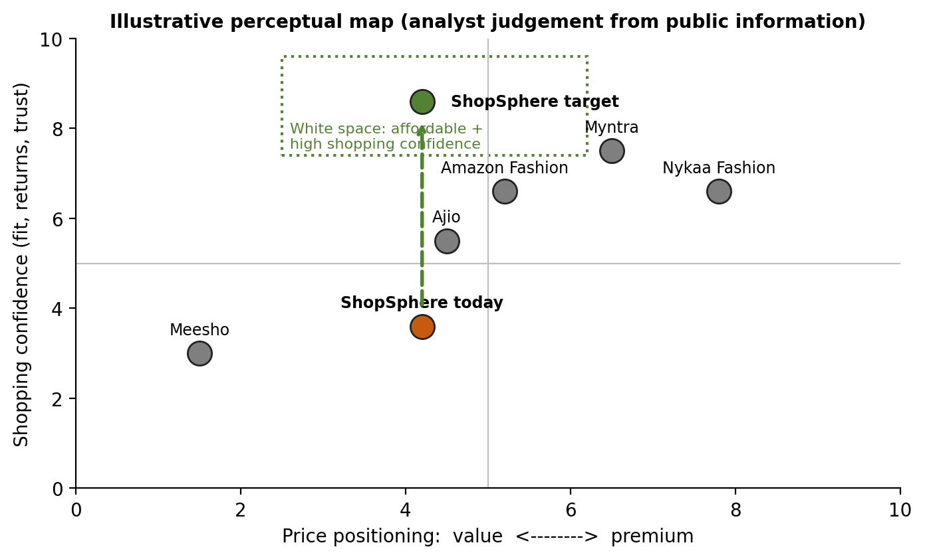
Figure 3: Perceptual map showing the affordable, high-confidence white space

5.2 Core Positioning Statement
Element | Statement
Target | Style-conscious online shoppers in India (first wave: Festive Planners aged 24 to 35; second wave: trust-seeking shoppers in Tier-2/3 cities)
Frame of reference | Online fashion and lifestyle marketplaces
Point of difference | Shopping confidence: fit guidance, a price with no surprises, a firm delivery date and easy returns
Reason to believe | Fit tags and photo reviews on every product; total price shown from the cart; delivery date by pincode; 3-tap returns with a 2-day refund target
Positioning statement | For style-conscious online shoppers who are tired of guessing size and price, ShopSphere is the fashion platform where you can fit it, trust it and keep it, because every product shows the real fit, the real price and a firm delivery date, and returns take three taps.
Tagline | Fit it. Trust it. Keep it.

5.3 Segment-Specific Positioning
Segment | Message | Proof points
S1 Festive Planners | Outfits that fit your occasion and arrive before it. | Delivery date by pincode; size help; photo reviews; easy exchange.
S2 Budget Starters | Look great, pay less, share the savings. | First-order offer; referral reward; student-friendly price band.
S3 Trust-Seeking Tier-2/3 | Genuine products. Pay on delivery. Easy returns. | COD, secure payment badges, regional-language support, clear return policy.

5.4 Messaging House
Umbrella promise | Pillar 1: Fit it | Pillar 2: Trust it | Pillar 3: Keep it
"Shop with Confidence" | Real fit tags, model measurements, size help | Total price upfront, delivery date, secure payments, verified reviews | 3-tap returns, exchange-first, refunds in 2 days
Tone of voice | Friendly, honest, practical; speaks like a stylish friend, not a salesperson | Avoids hype and fake urgency | Uses simple English and Hindi, regional language for S3

Messaging guardrails: no fake MRP or fake countdowns, claims must match product behaviour (for example, "refund in 2 days" is shown only where the SLA is met), and all offers are shown with clear terms. Trust is the product, so over-promising is the biggest brand risk.

6. Marketing Mix
The mix follows the 4 Ps (Product, Price, Place, Promotion), with a short extension for people, process and physical evidence because service quality drives the confidence promise.

6.1 Product
- Core offer: Launch features as defined in Section 2.1, released behind feature flags so they can be turned off individually.
- Assortment: Four curated launch collections: Festive Edit (ethnic and occasion wear), Work Edit, Wedding Guest Edit and Everyday Basics. Each has size-tagged hero products with photo reviews at launch.
- Quality: A supplier scorecard on fit accuracy, photo-versus-product match and defect rate; low scorers are de-ranked, since returns cost Rs 185 or more each.
- Packaging: Sturdy, reusable return-ready packaging with a return label slip; a thank-you card with a QR code for photo reviews.
- Post-launch roadmap: Fit assistant beta, wishlist price-drop alerts, loyalty tiers (see roadmap in Section 8.3).

6.2 Price
Pricing is value-based and transparent. The aim is to be seen as fairly priced and honest rather than the cheapest, since the cheapest position is held by value players and erodes margin.
Price element | Decision
Price architecture | Entry band Rs 399 to 799 (35% of assortment), core band Rs 800 to 1,999 (45%), premium band Rs 2,000 to 4,999 (20%). Expected AOV of about Rs 1,892.
Delivery fee | Free above Rs 1,499; Rs 79 below, shown in the cart before any login. The threshold nudges baskets toward the AOV target.
COD | Available in serviceable pincodes with a Rs 29 handling fee, waived on a first order; online payment gets small perks.
Margin guardrail | Gross margin floor of 25% on any promoted item; offers capped by budget; no price below cost.
Honest pricing | Real MRP only; no inflated strike-through prices; price-match message on selected hero products.
Payment options | UPI, cards, wallets, no-cost EMI on Rs 3,000 or more (bank-funded), COD.

Launch offers
Offer | Mechanics | Why
First-order offer | Rs 150 off on first order of Rs 999 or more; auto-applied, no coupon code | Lowers first-purchase risk; removes coupon hunting
Refer a friend | Give Rs 150, get Rs 150 (both on a Rs 999+ order); cost Rs 300 per successful referral | Cheaper than the Rs 381 blended CAC and builds trust
Festive Fit Fest | Up to 40% off the Festive Edit, with half the discount funded by suppliers | Drives volume without margin damage
Bank and wallet offers | Co-funded by payment partners | Shifts cost off ShopSphere; supports UPI/online mix
Waitlist early access | Early access to launch offers and a free-delivery pass for 7 days | Builds the 40,000 waitlist before L-Day

Offer economics check
Using conservative post-launch assumptions (AOV Rs 1,892, return rate 26.75%, return cost Rs 185), contribution per order is Rs 278 without a discount. With the Rs 150 first-order offer it falls to Rs 171. Assuming 60% of new customers redeem the offer, the blended first-order contribution is 0.6 x Rs 171 + 0.4 x Rs 278 = Rs 214. Total first-order and referral offer cost is about Rs 16.0 lakh (17,724 new customers x 60% x Rs 150), so the offer fund is set at Rs 16 lakh. Because first orders remain contribution-positive, the offer is affordable; repeat purchases then earn the higher full-price contribution.

6.3 Place (Distribution)
Element | Plan | Rationale
Primary channel | Mobile app (target 58% of orders); fast mobile web (PWA-style) for ad traffic; desktop for browsing | App converts 2.5x mobile web; push and CRM are cheap
Social commerce | Shoppable Instagram and YouTube links; WhatsApp catalogue and order updates | Meets S1 and S3 where they discover and talk
Geographic rollout | Wave 1 (L-Day): Delhi NCR, Mumbai, Bengaluru, Hyderabad, Pune, Chandigarh, Jaipur, Lucknow. Wave 2 (from December): Tier-2/3 pincodes by readiness | Protects delivery promise; follows S1 then S3
Fulfilment | North, west and south hubs; two primary courier partners plus a backup; metro delivery 2 to 3 days, Tier-2 3 to 5 days, Tier-3 5 to 7 days | Delivery dates are only shown where the SLA can be met
Returns network | Doorstep pickup in all wave-1 pincodes; return-to-origin quality check; exchange-first | Keeps return cost near Rs 170 to 185
Partnerships | Payment partners (UPI apps, banks), creator collectives, regional community groups | Distribution and trust at low cost

6.4 Promotion
The promotion plan has a Rs 75 lakh launch budget over 10 weeks, allocated by expected cost of acquiring a customer in each channel (Figure 4 and table below). Channel CAC values are planning assumptions to be replaced by actuals within the first two weeks.
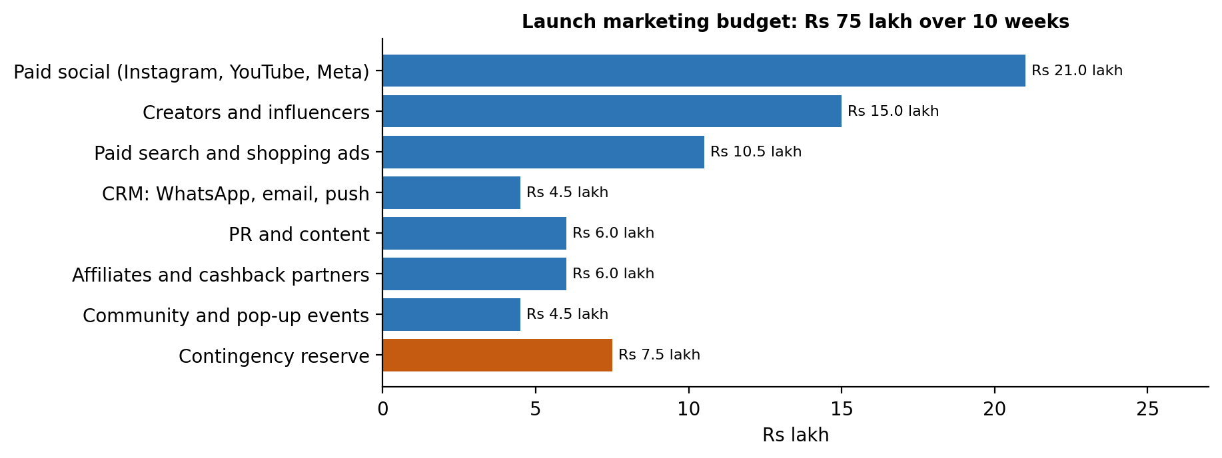
Figure 4: Launch marketing budget allocation
Channel | Share | Spend | Assumed CAC | New customers | Role
Paid social (Instagram, YouTube, Meta) | 28% | Rs 21.0 lakh | Rs 520 | 4,038 | Reach and conversion for S1
Creators and influencers | 20% | Rs 15.0 lakh | Rs 450 | 3,333 | Trust and styling content
Paid search and shopping ads | 14% | Rs 10.5 lakh | Rs 380 | 2,763 | Capture high intent
CRM: WhatsApp, email, push | 6% | Rs 4.5 lakh | Rs 120 | 3,750 | Waitlist and retargeting
PR and content | 8% | Rs 6.0 lakh | Rs 600 | 1,000 | Credibility and launch story
Affiliates and cashback partners | 8% | Rs 6.0 lakh | Rs 350 | 1,714 | Value-seeking traffic
Community and pop-up events | 6% | Rs 4.5 lakh | Rs 400 | 1,125 | Local trust for S3 (Wave 2)
Contingency reserve | 10% | Rs 7.5 lakh | - | - | Reallocate to best-performing channel
Total (excl. contingency) | 90% | Rs 67.5 lakh | Rs 381 | 17,724 | Blended CAC is below the Rs 421 baseline

Promotion by phase
Phase | Activities | Key messages
Pre-launch (19 Oct to 1 Nov) | Teaser reels with a "something fitting is coming" theme; waitlist page with early-access reward; creator seeding with 30 micro and 8 mid-tier creators; PR embargo briefings; staff and loyal-customer beta | "Never guess your size again." "Get in early."
Launch (2 to 8 Nov) | Hero film (60 s and 15 s cuts); Launch Day email, WhatsApp and push to waitlist; creator go-live; paid social and search burst; press release; festive landing pages; Diwali gifting guide | "Fit it. Trust it. Keep it." Festive offers, delivery before Diwali.
Post-launch (9 Nov to 6 Dec) | Retargeting by browse behaviour; photo-review and UGC contest; referral push; wedding-season edit; post-purchase review and replenishment journeys; Wave 2 regional campaigns | "Your look, delivered on time." Social proof and referral rewards.

6.5 Extended Mix: People, Process, Physical Evidence
- People: Support capacity is doubled for 2 to 15 Nov; agents are trained on fit, returns and refund scripts; WhatsApp support runs 8am to 11pm.
- Process: Return and refund workflows are the main service promise; process owners track the 2-day refund SLA daily.
- Physical evidence: Return-ready packaging, a branded delivery slip, an order tracking page and visible trust badges communicate reliability.

7. Launch Plan and Calendar

7.1 Timeline Overview
The launch runs in four phases. Launch day is Monday 2 November 2026, about six days before Diwali (expected around 8 November 2026; verify the date). A code freeze from 31 October protects stability, and only content and configuration changes are allowed through 10 November.
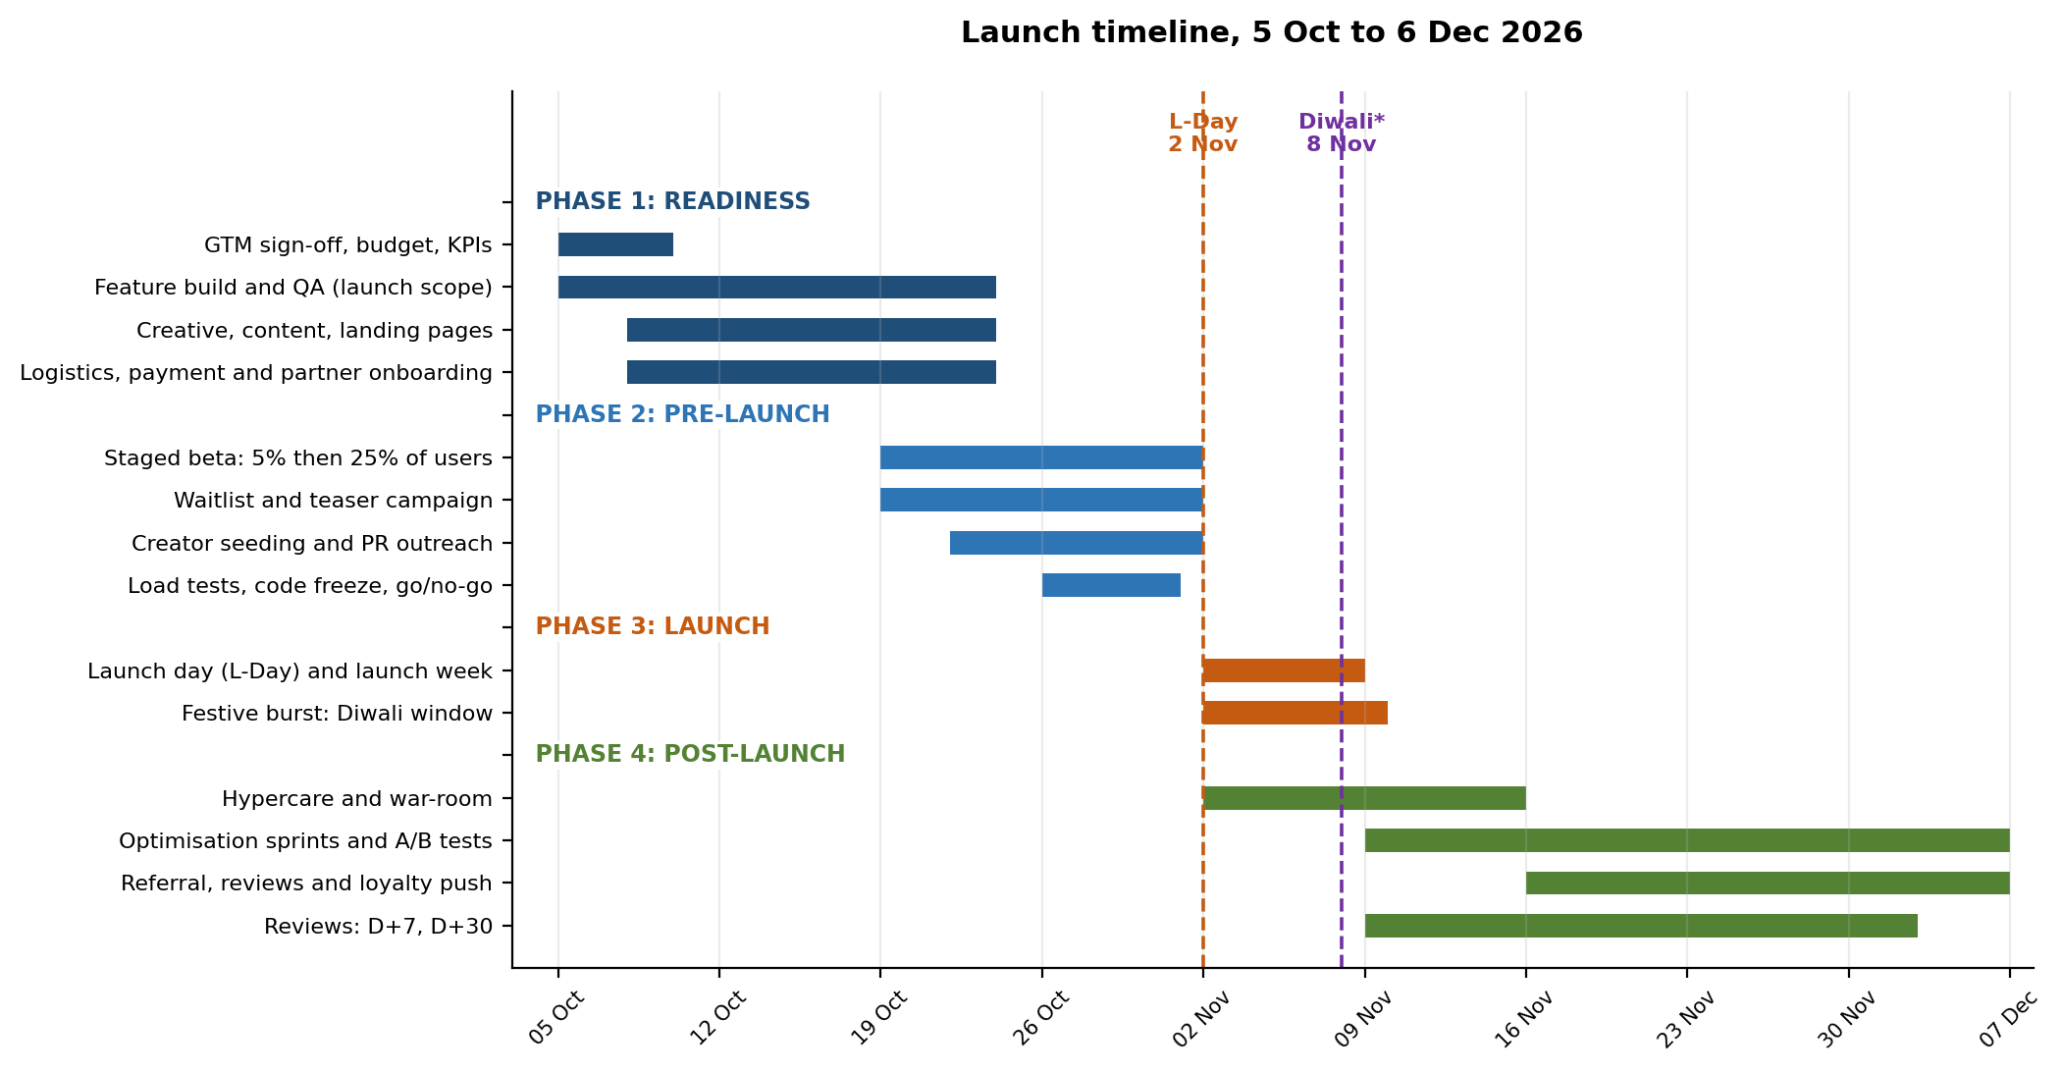
Figure 5: Launch timeline by workstream (*Diwali date to be verified)

7.2 Detailed Launch Calendar
Date | Activity | Owner | Output / checkpoint
5 to 9 Oct (T-28) | GTM plan sign-off; approve budget, offers and KPI targets; finalise launch scope | PM, Head of Product, Finance | Signed-off plan and budget
5 to 23 Oct | Build and QA launch features; fix top payment and speed issues | Engineering, QA | Release candidate 23 Oct
8 to 23 Oct | Produce hero film, creatives, landing pages, CRM journeys, help-centre content | Marketing, Design, CRM | Asset library approved
8 to 23 Oct | Onboard payment and logistics partners; test delivery-date accuracy; set SLAs | Operations, Engineering | SLA sheet; pincode list
19 Oct (T-14) | Open waitlist and teaser campaign; start staged beta at 5% (staff, loyal users) | Marketing, Product | Waitlist counter; beta feedback
22 Oct | Creator seeding begins (products and briefs sent) | Marketing | Creator content calendar
26 Oct (T-7) | Increase beta to 25%; start load tests; PR briefings under embargo | Product, Engineering, PR | Load test report; media list
29 Oct | Go/no-go meeting 1 (readiness checklist, Section 7.4) | Launch lead | Decision log
31 Oct (T-2) | Code freeze; final regression; support training complete; war-room set up | Engineering, Support | Freeze confirmed
1 Nov (T-1) | Go/no-go meeting 2; confirm inventory and carrier capacity; schedule communications | Launch lead, Ops | Final go decision
2 Nov (L-Day) | Launch: ramp to 100%, send waitlist communications, release hero film, creators go live | All teams | Day-1 dashboard
3 to 8 Nov | Daily war-room; scale spend to best channels; Diwali gifting push; monitor delivery and support | Marketing, Ops, Product | Daily stand-up notes
9 Nov (D+7) | Review 1: stability, funnel, early CAC; decide scale, hold or fix | Launch lead, Analytics | D+7 report
10 to 15 Nov | Hypercare ends; start A/B tests (guest checkout copy, free-shipping bar, fit prompts) | Product, Data | Test backlog and results
16 Nov | Launch referral and review-incentive campaign; start wedding-season edit | Marketing, CRM | Referral and review volumes
2 Dec (D+30) | Review 2: KPI scorecard against targets; ROI check; Wave 2 go/no-go | Launch lead, Finance | D+30 report and Wave 2 decision
6 Dec onward | Wave 2 (Tier-2/3 rollout) and optimisation sprints; D+60 and D+90 reviews in January | Product, Marketing | Updated plan

7.3 Launch Day Run-of-Show (2 November)
Time | Action | Owner
06:00 | Final health checks: servers, payment gateways, inventory sync, delivery-date engine | Engineering
08:00 | Final go decision in war-room | Launch lead
09:00 | Feature flags to 100%; internal smoke test with live orders | Engineering, QA
10:00 | Waitlist email, WhatsApp and push go out | CRM
11:00 | Press release, hero film and social posts live | Marketing, PR
12:00 | Creators go live; paid social and search budgets ramp | Marketing
14:00 | Checkpoint 1: error rate, payment success, add-to-cart rate, support queue | Product, Analytics
18:00 | Checkpoint 2: reallocate spend to top channels; fix any content or price issues | Marketing
20:00 | Evening peak check; support staffing confirmed for night | Ops, Support
22:00 | Day-1 snapshot and retro; plan for Day 2 | Launch lead

7.4 Staged Rollout and Go/No-Go Checklist
Release is staged to limit risk: 5% of users (staff and loyal customers) from 19 October, 25% from 26 October and 100% on launch day. Each stage needs to pass the checks below before moving forward.
Readiness check | Pass criterion | Owner
Payment success rate in beta | 90% or higher, no gateway outages | Engineering
Page speed on mobile (LCP) | 3.0 s or lower at launch (2.5 s target) | Engineering
Load test | Handles 2x expected peak with error rate under 1% | Engineering
Delivery-date accuracy in beta | 90% of orders arrive by promised date | Operations
Return and refund flow | End-to-end tested; refund SLA verifiable | Operations, Finance
Support readiness | Trained team, scripts and 2x capacity in place | Support
Inventory depth for hero products | At least 14 days of expected demand in stock | Operations
Offer and legal checks | Terms approved; no misleading claims | Legal, Marketing
Tracking and dashboards | Funnel and campaign events verified | Data

7.5 Roles and Responsibilities (RACI)
R = Responsible, A = Accountable, C = Consulted, I = Informed.
Activity | PM | Eng. | Mktg | Ops | CRM | Supp. | Finance
GTM plan and KPIs | A/R | C | C | C | C | I | C
Feature build and QA | A | R | I | I | I | C | I
Campaign and creative | C | I | A/R | I | R | I | C
Logistics and returns SLAs | C | C | I | A/R | I | C | C
Support readiness | C | I | I | C | I | A/R | I
Waitlist and CRM journeys | C | C | C | I | A/R | I | I
Launch day command | A/R | R | R | R | R | R | I
Budget and ROI tracking | C | I | C | I | I | I | A/R

8. Measurement and Post-Launch Evaluation

8.1 Launch Dashboard
A single launch dashboard is reviewed daily during the first two weeks and weekly after that. It uses leading indicators (traffic, waitlist, add-to-cart, payment success, support queue) and lagging indicators (orders, CAC, return rate, NPS, repeat purchase).
Layer | KPIs | Frequency | Source
Reach | Sessions, waitlist sign-ups, creator views, branded search | Daily | Analytics, ad platforms
Conversion | Add-to-cart, checkout completion, payment success, conversion rate | Daily | Analytics, gateway
Acquisition efficiency | New customers, CAC by channel, ROAS, redemption of first-order offer | Daily, weekly | Order data, ad spend
Experience | On-time delivery, support tickets, refund time, NPS, return rate | Daily, weekly | Ops, helpdesk, survey
Value | AOV, contribution per order, net contribution, 90-day repeat | Weekly, monthly | Finance, CRM

8.2 Review Cadence and Decision Rules
Review | Focus | Decision rules
Daily (Nov 2 to 15) | Stability and funnel health | Payment success under 88% or error rate over 1%: fix first, pause paid ramp. Conversion below the 1.18% baseline for 3 days: check flags and consider rollback of the weakest feature.
D+7 (9 Nov) | Early traction, CAC, support load | Scale channels with CAC under Rs 380; reduce those above Rs 480; add support capacity if first-response time exceeds target.
D+30 (2 Dec) | KPI scorecard, ROI, customer feedback | Green if at least 90% of D+30 targets met: proceed with Wave 2. Amber (70 to 90%): fix specific gaps before Wave 2. Red (below 70%): pause expansion and re-diagnose.
D+60 and D+90 (Jan) | Retention, repeat rate, LTV, return rate | Decide on loyalty tiers, fit-assistant investment and next-quarter budget.

8.3 Post-Launch Optimisation Roadmap
- Weeks 2 to 6: Run A/B tests on free-shipping bar placement, guest-checkout copy, size-help prompts and returns messaging (sample-size method from the performance study).
- Weeks 3 to 6: Scale the top channels and creators; cut low performers; launch referral and review-incentive journeys; start wedding-season edit.
- From December: Roll out to Tier-2/3 pincodes (Wave 2) with regional-language content, COD and community partnerships.
- Q1 2027: Fit assistant, loyalty tiers and predictive messaging, based on data from the first 90 days.

9. Budget and Return on Investment
Item | Calculation / basis | Value
Marketing budget (10 weeks) | From Section 6.4 | Rs 75.0 lakh
of which acquisition media | 90% of budget (contingency excluded) | Rs 67.5 lakh
First-order and referral offer fund | New customers x 60% redemption x Rs 150 | Rs 16.0 lakh
New customers acquired | Sum of spend / CAC by channel | 17,724
Blended CAC | Rs 67.5 lakh / 17,724 | Rs 381
Blended first-order contribution | 0.6 x discounted + 0.4 x full-price | Rs 214
Contribution per later order (conservative) | Section 6.2 | Rs 278
90-day contribution from new customers | 17,724 x (Rs 214 + 22% x Rs 278) | Rs 48.7 lakh
12-month LTV per new customer | Rs 214 + 0.8 x Rs 278 | Rs 436
12-month cohort contribution | 17,724 x Rs 436 | Rs 77.2 lakh
Return on media spend: 90 days / 12 months | Contribution / Rs 67.5 lakh | 0.72x / 1.14x

Reading the result: The offer cost is already deducted from first-order contribution, so it is not counted twice. New customers pay back media spend in about a year, not within the launch window, which is normal for acquisition-led launches. The larger and faster return comes from converting existing traffic better: the performance study estimated Rs 28 to 62 lakh of extra net contribution per quarter from the same improvements, at no extra media spend. If the whole contingency reserve is used, the 12-month return on the full Rs 75 lakh is 1.03x.
Sensitivity: if actual CAC is 20% higher than planned (about Rs 457), the 12-month return on media drops to roughly 0.95x, which would trigger reallocation toward CRM, referrals and creators at the D+7 review. If the redemption rate of the first-order offer is 80%, offer cost rises to about Rs 21 lakh and first-order contribution falls; the offer cap would be tightened.

10. Risks and Contingency Plans
Risk | Likelihood / impact | Early warning | Contingency
Site or payment outage in the peak | Medium / High | Error rate, payment success below 88% | Code freeze, load tests, standby engineers, fallback gateway; pause paid ramp if needed.
Delivery delays cause the promise to fail | Medium / High | On-time rate under 90%, ticket spike | Show conservative dates; use backup carrier; proactive WhatsApp updates; delay voucher.
Competitor festive discounting lowers conversion | High / Medium | Conversion down 15% for 2 weeks; branded search share | Focus on confidence message and loyal segments; targeted rather than site-wide offers.
Ad costs rise and CAC overshoots | High / Medium | CAC above Rs 480 | Shift to CRM, referrals and creators; use the contingency reserve selectively.
Offer abuse or fraud | Medium / Medium | Multiple accounts per device, high returns by new users | Phone-number and device checks, offer limits, return-pattern monitoring.
Return rate rises during the festive peak | High / Medium | Return rate above 30% | Exchange-first prompts, size help, supplier scorecards, partial refund rules for misuse.
Features not ready at L-Day | Medium / Medium | QA pass rate, open critical bugs on 29 Oct | Launch with flags; delay the weakest feature; keep marketing claims aligned with live features.
Brand claims not met (trust damage) | Low / High | Reviews and social mentions | Honest claims only; fast response protocol and public fixes.

11. Conclusion
ShopSphere's earlier diagnosis showed that shoppers lose confidence at three moments: when the price changes, when they cannot judge fit and when they imagine returning an item. ShopSphere 2.0 turns the fixes for these moments into a single, simple promise, "Fit it. Trust it. Keep it." and launches it where it matters most, with festive planners first and trust-seeking smaller-city shoppers second.
The plan combines analytical segmentation, clear positioning, a 4P mix with checked unit economics and a dated launch calendar with staged rollout, go/no-go gates and post-launch review rules. Its key strength is not an aggressive discount but the combination of a reliable experience and disciplined spend. Used together with the KPI framework from the performance study, it gives the product team a repeatable way to launch, measure and adjust.

Appendix A: Assumptions Register
Assumption | Value | Source / status
Online fashion shoppers in India | 120 million | Estimate within public ranges; verify
Annual spend per shopper | Rs 6,000 | Assumption
Target segments share / serviceable pincodes | 50% / 70% | Segmentation and delivery coverage assumptions
Current run-rate GMV | Rs 26.3 crore a year | Simulated (Q3 x 4)
Gross margin; fulfilment; payment fee | 35%; Rs 120; 2% | Simulated, typical range
Post-launch AOV; return rate; return cost | Rs 1,892; 26.75%; Rs 185 | Conservative case from performance study
Channel CAC values | Rs 120 to 600 by channel | Planning assumptions; replace with actuals
Offer redemption by new customers | 60% | Assumption
Diwali 2026 | About 8 November | Verify against an official calendar

References and Public Sources
The plan draws on the following public sources. Check the latest editions before quoting figures.
- Bain & Company and Flipkart: How India Shops Online (online shopper growth and Tier-2+ trends).
- Redseer Strategy Consultants: India e-commerce and festive-season sales reports.
- IAMAI and TRAI: Internet users and broadband subscriber data.
- NPCI: UPI monthly transaction statistics.
- Baymard Institute: Checkout usability and cart-abandonment research.
- Nielsen Norman Group: E-commerce UX research.
- Google / Think with Google: Mobile speed and consumer behaviour insights.
- Kotler and Keller, Marketing Management: STP and 4P frameworks; Geoffrey Moore and April Dunford on positioning.
- Public company announcements and app-store reviews of leading Indian fashion platforms.
- Earlier deliverables: Week 4 customer journey map and final-week performance evaluation framework.

